**Exercise 3: Stored Procedures**

**Scenario 1:** The bank needs to process monthly interest for all savings accounts.

**Question:** Write a stored procedure **ProcessMonthlyInterest** that calculates and updates the balance of all savings accounts by applying an interest rate of 1% to the current balance.

CREATE OR REPLACE PROCEDURE ProcessMonthlyInterest AS

BEGIN

UPDATE Accounts

SET Balance = Balance * 1.01

WHERE AccountType = 'Savings';

COMMIT;

DBMS_OUTPUT.PUT_LINE('Monthly interest processed for all savings accounts.');

END;

/

SET SERVEROUTPUT ON;

BEGIN

ProcessMonthlyInterest;

END;

/

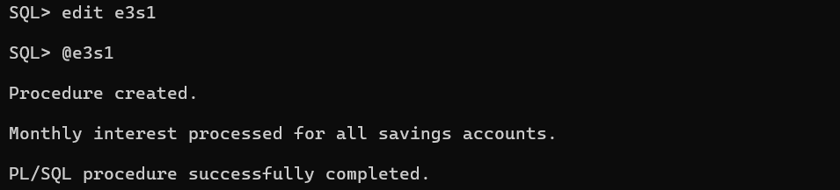

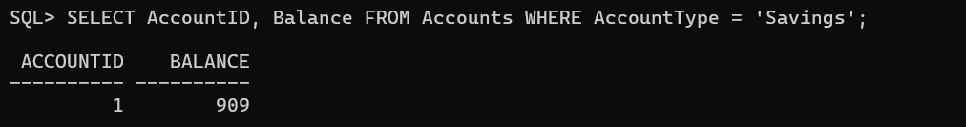

**Scenario 2:** The bank wants to implement a bonus scheme for employees based on their performance.

**Question:** Write a stored procedure **UpdateEmployeeBonus** that updates the salary of employees in a given department by adding a bonus percentage passed as a parameter.

CREATE OR REPLACE PROCEDURE UpdateEmployeeBonus(

p_department IN VARCHAR2,

p_bonus_percentage IN NUMBER

) AS

BEGIN

-- Update salaries of employees in the specified department with the bonus

UPDATE Employees

SET Salary = Salary * (1 + p_bonus_percentage / 100)

WHERE Department = p_department;

COMMIT;

DBMS_OUTPUT.PUT_LINE('Bonus updated for employees in department: ' || p_department);

END;

/

SET SERVEROUTPUT ON;

BEGIN

UpdateEmployeeBonus('IT', 10);

END;

/

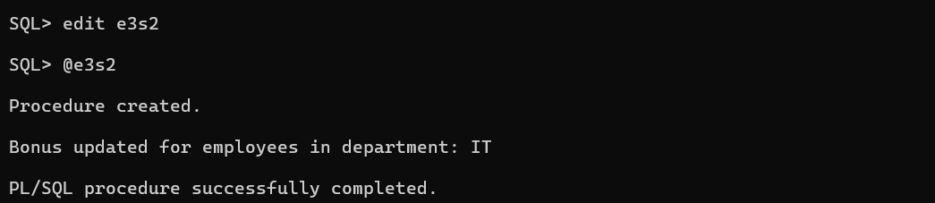

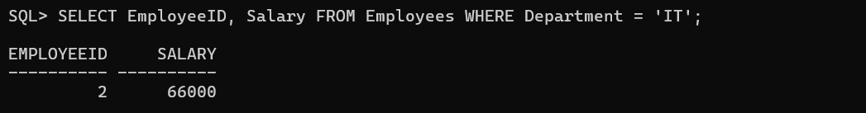

**Scenario 3:** Customers should be able to transfer funds between their accounts.

**Question:** Write a stored procedure **TransferFunds** that transfers a specified amount from one account to another, checking that the source account has sufficient balance before making the transfer.

CREATE OR REPLACE PROCEDURE TransferFunds(

p_from_account_id IN NUMBER,

p_to_account_id IN NUMBER,

p_amount IN NUMBER

) AS

v_from_balance NUMBER;

v_to_balance NUMBER;

BEGIN

BEGIN

SELECT Balance INTO v_from_balance FROM Accounts WHERE AccountID = p_from_account_id;

SELECT Balance INTO v_to_balance FROM Accounts WHERE AccountID = p_to_account_id;

IF v_from_balance < p_amount THEN

RAISE_APPLICATION_ERROR(-20001, 'Insufficient funds for transfer.');

END IF;

UPDATE Accounts

SET Balance = Balance - p_amount

WHERE AccountID = p_from_account_id;

UPDATE Accounts

SET Balance = Balance + p_amount

WHERE AccountID = p_to_account_id;

COMMIT;

DBMS_OUTPUT.PUT_LINE('Transfer completed successfully.');

EXCEPTION

WHEN OTHERS THEN

ROLLBACK;

DBMS_OUTPUT.PUT_LINE('Error during transfer: ' || SQLERRM);

END;

END;

/

SET SERVEROUTPUT ON;

BEGIN

TransferFunds(1, 2, 100);

END;

/

